Defuse the Bomb
A CSC 102 Project

Team: M = E/C^2

Ethan Pineiro, Charles Campbell, Charles Kahlenberg

BOMB DEFUSAL MANUAL

Version 1
Verification Code: <enter your code>
The Game
This project is inspired by multi-phase escape-and-puzzle games, but reimagines the concept through a narrative-driven experience centered on the rivalry between Charles 1 and Charles 2. In this storyline, Charles 2 wakes up strapped to a chair deep inside Charles 1’s underground facility after a petty but escalating dispute over who deserves the name “Charles.” To survive, Charles 2 must escape the facility by completing a sequence of interactive challenges, each represented as a minigame.

While the original inspiration exists purely as software, our version blends both digital gameplay and optional physical hardware, allowing the escape sequence to be experienced through a GUI, a Raspberry Pi–powered device, or both. Players can interact directly with the bomb phases while simultaneously referencing this document, effectively acting as both the trapped protagonist and the “experts” guiding the escape.

At the core of the system is a Raspberry Pi, which functions as the game’s hardware controller. It interfaces with real-world components such as buttons, switches, LEDs, and keypads, enabling a hybrid physical-digital experience. The underlying software is written in Python using Pygame for graphics and NumPy for logic. This project was developed as part of a larger exploration into interactive systems and game design within the Computer Science Program at the University of Tampa.

Defusing Bomb
The bomb will “explode” when its countdown reaches 0:00 or when too many strikes have occurred. You defuse the bomb by disarming all of its “phases” before the countdown expires.
Phases
The bomb has four phases, each of which must be disarmed. Instructions for disarming the phases are provided in this document.
Strikes
A mistake in disarming a phase results in a strike. Get too many strikes, and the bomb “explodes”.
Information
A different version of the bomb is randomly presented each time it is “booted”. There are 6,720 unique versions of the bomb with a whopping 1,176,000 possible variations!
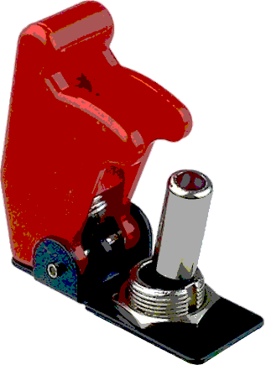
Regarding the Toggles

The Switches Game challenges the player to interpret scrambled binary values using physical toggle switches. The game consists of five rounds, each increasing in difficulty. In every round, the player is given a target number and a set of four switches, each representing a power of two. However, the twist is that the order of the binary positions is randomized.

For example, instead of the standard left-to-right binary order (8, 4, 2, 1), a round might present the switches as (8, 2, 1, 4) or any other permutation. Later rounds expand the pool of values, producing combinations like (256, 32, 1, 8). The player must flip the correct switches so their sum matches the target number. Passing all five rounds successfully unlocks the next phase of the escape sequence.
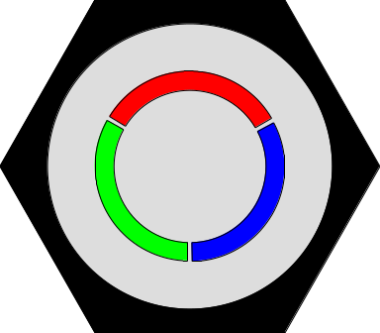
Regarding the Button

The Button serves multiple purposes throughout the game, acting as both a progression tool and an action input. During story and dialogue sequences, the button is used simply to advance text and move the narrative forward. In the Switches Minigame, the button becomes a critical control: once the player has set their toggle-switch combination, pressing the button confirms the input and checks whether the selected values match the target number.
Regarding the Keypad

The Keypad is used in two major parts of the game, each with a different purpose. During the Panel Removal sequence, the keypad is used to enter the numbers printed on the panel’s four corners in clockwise order (1, 2, 3, 4), allowing Charles 2 to unlock and remove the cover. Later, in the Safe Minigame, the keypad functions like a traditional safe input system. This phase consists of 8 rounds, each increasing in difficulty: the player must memorize a sequence of buttons (first 1, then 2, then 3, then 4, etc.) and repeat them back in the correct order. After completing all 8 rounds, the player is prompted to enter the final combination, which is formed by taking the first number from each round. Entering this code successfully unlocks the safe and advances the escape.
Regarding the Wires
In the Wires Minigame, the player is guided step-by-step through reconnecting a series of wires inside the panel. The game prompts the user with exactly which wire to connect next, and the player must follow this sequence in the correct order. Connecting the wrong wire or skipping ahead results in a strike, adding pressure to stay focused and precise. Completing the wiring sequence correctly allows Charles 2 to restore power and progress to the next phase of the escape.

